Segmentation of Brain Tissue Using Self Supervised Learning



Abstract

The segmentation of brain tissue in medical imaging is crucial for diagnosing and treating various neurological conditions. Traditional segmentation methods often require extensive labeled data and are computationally intensive, making them impractical for large-scale or resource-constrained applications. This research addresses the problem of developing a framework for incrementally fine-tuning a multi-class segmentation of multi-channel images of a rat brain section using self-supervised learning for whole-brain tissue mapping.
The primary objective of this study is to develop and evaluate a self-supervised learning model for accurately segmenting 10 anatomical regions of interest in the brain. We employed the DINOv2 model, leveraging its ability to learn meaningful representations from unlabeled data to enhance accuracy and efficiency in brain tissue mapping. The model was trained on a dataset created using seven biomarkers with Napari.
Our results demonstrate that the self-supervised learning approach achieves competitive performance compared to fully supervised methods, with significant improvements in segmentation accuracy and computational efficiency. The model effectively distinguishes between different anatomical brain regions.
This method can potentially accelerate understanding of the effects of drugs on the brain at a system-level, offering valuable insights into brain function and pathology. The primary goal of this toolkit is to map the entire brain. By combining advanced imaging and the DINOv2 model, we can potentially create detailed maps of brain regions and structures.
These findings highlight the potential of self-supervised learning in medical image analysis, offering a viable solution for brain tissue segmentation without the need for large annotated datasets. Future work will focus on refining the model's architecture, incorporating additional data sources, and exploring its application to other types of medical imaging.

Table of Contents :

List of Figures …………………………………………………………………iii
List of Tables …………………………………………………………………..iv
Chapter : 1. Introduction ……………………………………………………………………..1
1.1 Problem Statement and Objectives ……………………………………………….1
1.2 Multi-Class Segmentation of Rat Brain…………………………………………..2
Chapter : 2. Literature Review and Background ……………………………………………..3
2.1 Immunofluorescence Imaging…………………………………………………….3
2.2 Dino V2 Model …………………………………………………………………...4
2.3 Exploration of Seven Biomarkers for Neurological Imaging……………………..5
2.4 Evaluation Metrics ……………………………………………………………….5
Chapter : 3. Dataset …………………………………………………………………………..7
3.1 Creating The Dataset Using Biomarkers ……………………………………...…7
3.2 Mask image ……………………………………………………………………...8
3.3 Performing Exploratory Data Analysis on mask image ………………………...9
3.4 Data visualisation ………………………………………………………………..11
3.5 Normalising pixel values ………………………………………………………..11
3.6 Splitting the data into train and test ……………………………………………..12
Chapter : 4. Library Setup and Background ………………………………………………...14
4.1 Significance of importing libraries and packages ……………………………...14
Chapter : 5. Segmentation Map ……………………………………………………………..16
5.1 Mapping every class to a random color …………………………………………16
5.2 Visualizing Segmentation Maps on Images ……………………………………..17
Chapter 6 : Model ……………………………………………………………………………19
6.1 Creating Pytorch Dataset ………………………………………………………..19
6.2 Data Augmentation and Normalisation …………………………………………19
6.3 Dino V2 as Encoder ……………………………………………………………...20
6.4 Verifying Model Output and Loss Computation …………………………………22
6.5 Training the Model ………………………………………………………………22
Chapter : 7. Approach ……………………………………………………………………….24
7.1 Training Model With 7 Biomarkers ……………………………………………...24
7.1.1 Using linear classifier as decoder ………………………………………………24
7.1.1.1 Training on larger number of epochs …………………………………………24
7.1.1.2 Fine Tuning Hyperparameters ……………………………………………..2
7.1.2 Using 2-D convolutional layers ……………………………………………….29
7.2 Cropping Images Dataset ………………………………………………………30
7.3 Binary and Multi-Class Classification Combined ………………………………34
Chapter : 8. Analysis and Results …………………………………………………………...36
8.1 Training Model With 7 Biomarkers ……………………………………………...36
8.1.1 Using linear classifier as decoder ………………………………………………36
8.1.1.1 Training on larger number of epochs ………………………………….........36
8.1.1.2 Fine Tuning Hyperparameters ……………………………………………...37
8.1.2 Using 2-D convolutional layers ……………………………………………….37
8.2 Cropping Images Dataset ………………………………………………………..38
8.3 Binary and Multi-Class Classification Combined ……………………………....39
Chapter : 9.Conclusions ……………………………………………………………………..42
References ……………………………………………………………………………………44

List of Figures

Fig 1.1 Overview of Multiplex IHC staining and multispectral epifluorescence imaging…….3
Fig 1.2 DinoV2 model : Data processing pipeline……………………………………………..4
Fig 2.1 View of rat-brain tissue after staining with different biomarkers……………………..7
Fig 2.2 Combining and merging all the axes biomarker stains………………………………..8
Fig 2.3 Ground truth mask ……………………………………………………………………9
Fig 2.4 Pixel value distribution of data ………………………………………………………10
Fig 2.5 Non-zero pixel distribution ………………………………………………………….10
Fig 2.6 Data visualisation and exploration …………………………………………………...11
Fig 2.7 Train and test data …………………………………………………………………...13
Fig 3.1 Colour associated with each class …………………………………………………..17
Fig 3.2 Ground truth with assigned classes …………………………………………………18
Fig 4.1 IoU vs number of epochs for each brain region……………………………………..27
Fig 4.2 Cropping images dataset …………………………………………………………….32
Fig 5.1 Visualisation after training model respectively for 5 and 40 epochs ………………..36
Fig 5.2 Visualisation for 23 epochs with early stopping and its metrics …………………….37
Fig 5.3 Visualisation after 2 trials after implementation of hyperparameter tuning………….37
Fig 5.4 Visualisation After 5 trials at epoch 19 after hyperparameter tuning ………………..38
Fig 5.5 Visualisation after implementation of 2-D convolutional layers as decoder ………...39
Fig 5.6 Visualisation after training cropping images for respectively 2 and 5 epochs ………39
Fig 5.7 Visualisation after training cropping images for higher number of epochs ………….39
Fig 5.8 Metrics for final visualisation ………………………………………………………40
Fig 5.9 Visualisation after integrating multiple and binary approach ………………………41

List of Tables

Table 1.1 IOU for 10 classes implementing different models from research paper…………..42
Table 1.2 Performance metrics for all implemented approaches ……………………………42

Chapter : 1.Introduction

1.1 Problem Statement and Objectives

Problem Statement:
The objective of this study is to develop a methodological framework for the progressive refinement of a multi-class segmentation model applied to multi-channel rat brain section images, utilizing self-supervised learning. This research also aims to achieve Whole Brain Tissue Mapping, which involves creating a detailed map of diverse brain tissues based on the segmentation model's outcomes.
Objectives:
- Create a structured framework for processing and analyzing multiplexed immunofluorescence images from rat brain sections.
- Construct a multi-class segmentation model to accurately delineate 10 specific anatomical regions of interest in the brain. Utilize self-supervised learning techniques to train the model, reducing the need for manual annotations.
- Develop a methodology for gradually improving the segmentation model by fine tuning hyperparameters. This involves updating the model's parameters while retaining previously learned knowledge to adapt to new data effectively.
- Evaluate the performance of the segmentation model using quantitative metrics.Validate the whole brain tissue map against ground truth .

1.2 Multi-Class Segmentation of Rat Brain :
In the context of multi-class segmentation of rat brain anatomical regions, ten specific areas of interest have been identified for accurate segmentation. These regions are:
- Corpus callosum (cc)
- Medial habenular nucleus (MHb)
- Reticular thalamic nucleus (Rt)
- Mammillothalamic tract (mt)
- Sigmoid hypothalamic nucleus (Stg)
- Medial globus pallidus (MGP)
- Ventromedial hypothalamic nucleus (VMH)

- Optic tract (opt)
- Fimbria of the hippocampus (fi)
- Stria medullaris of the thalamus (sm)
These anatomical regions play crucial roles in brain function and connectivity, and accurately segmenting them is essential for various neuroscientific studies and medical applications

Chapter : 2.Literature Review and Background

2.1 Immunofluorescence Imaging
Highly multiplexed immunofluorescence imaging is an advanced technique that revolutionizes our ability to study the intricate details of brain structure and function. This method allows researchers to simultaneously visualize multiple biomarkers or molecules within brain tissue, providing a comprehensive view of the brain's cellular and molecular composition.
By employing this technique, researchers can select regions of interest where biomarkers are most visible. These selected regions are then used to form a 7-channel image, which enables the simultaneous visualization of multiple molecules within brain tissue.
The use of highly multiplexed immunofluorescence imaging has several advantages over traditional imaging methods. It allows for the study of multiple biomarkers in a single sample, reducing the amount of tissue needed for analysis. Additionally, it provides high spatial resolution, allowing researchers to pinpoint the exact location of biomarkers within the brain.
Overall, highly multiplexed immunofluorescence imaging is a powerful tool that enhances our understanding of the brain's molecular and cellular composition. It offers new insights into the complex mechanisms underlying brain function and provides valuable information for the development of novel therapeutic strategies for neurological disorders.

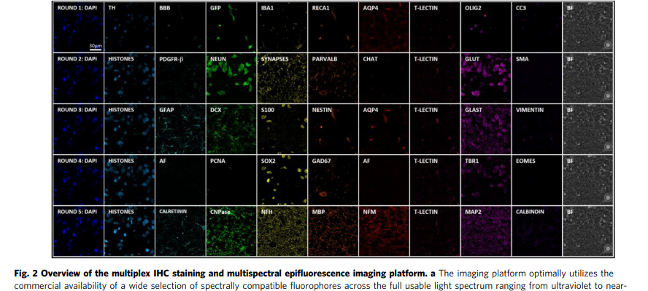
Fig 1.1 Overview of Multiplex IHC staining and multispectral epifluorescence imaging platform

2.2 DINO V2 Model
DINO V2 is an advanced self-supervised learning approach designed for training visual representations from unlabelled images. Developed as an evolution of the original DINO approach, DINO v2 builds upon the Vision Transformer (ViT) architecture, known for its effectiveness in capturing long-range dependencies in images.
The core concept behind DINO V2 is instance discrimination, where the model is trained to distinguish between different augmented views of the same image while ensuring that the features of different views of the same image are close to each other in the feature space. This encourages the model to learn meaningful representations by comparing different parts of the same image, without the need for manual annotations or labels.
One key innovation in DINO V2 is the use of a student-teacher approach. In this setup, there are two models: a student model and a teacher model. The teacher model provides guidance to the student model by producing more accurate outputs, which the student model tries to mimic during training. However, to prevent the student from simply memorizing the teacher's outputs, a form of "distillation" is applied. This means that the student is encouraged to learn a more generalized version of the task by matching not only the teacher's outputs but also the teacher's internal representations or features.
By incorporating the student-teacher approach, DINOV2 improves the quality of the learned features and enhances the model's performance on downstream tasks. This makes it a powerful tool for learning visual representations from unlabeled data, with applications in image classification, object detection, and image segmentation.

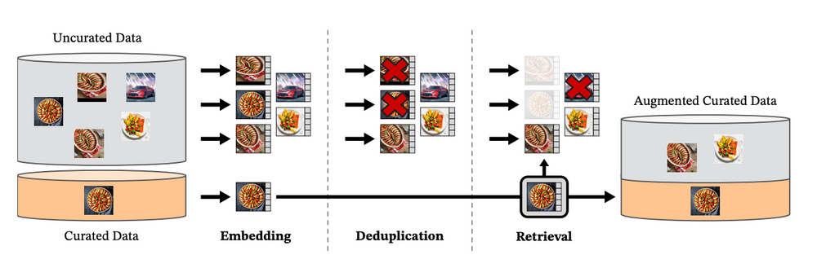
Fig 1.2 DinoV2 model : Data processing pipeline

2.3 Exploration of Seven Biomarkers for Neurological Imaging :

This research explores the use of seven biomarkers for neurological imaging, selecting regions of interest where these biomarkers are most visible to form a 7-channel image dataset.These biomarkers are specific to various cell types and cellular components within the brain, making them ideal for creating a comprehensive imaging dataset.

The selected biomarkers :
• CNPase (oligodendrocytes, soma and processes-specific)
• GFAP (astrocytes, processes-specific)
• NeuN (neurons, nucleus and soma-specific)
• OLIG2 (oligodendrocytes, nucleus-specific)
• Parvalbumin (interneurons, soma and processes-specific)
• S100 (astrocytes, nucleus and soma-specific)
• Tyrosine Hydroxylase (catecholaminergic neurons, soma and processes-specific)

2.4 Evaluation Metrics :

These metrics provide a comprehensive assessment of the model’s effectiveness in segmenting brain tissue regions.

Loss: The model achieved a loss , indicating the level of discrepancy between the predicted segmentations and the ground truth masks.we use a combination of cross-entropy loss and Dice loss to penalize incorrect predictions and encourage the model to produce accurate segmentations. A lower loss value indicates a better alignment between the predicted segmentations and the ground truth.

Accuracy: The model achieved an accuracy demonstrating its ability to correctly classify the majority of pixels.It provides an overall measure of the model's ability to correctly label each pixel. However, accuracy alone may not fully capture the model's performance, especially in cases with imbalanced class distributions.

Mean IoU: Mean IoU is a robust metric for evaluating segmentation performance. It calculates the intersection and union of the predicted and ground truth segmentation masks for each class, then averages these values across all classes.
The IoU is defined as:
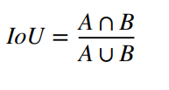
Mean IoU provides a comprehensive measure of how well the model segments different classes, considering both precision and recall. A higher mean IoU indicates better segmentation performance.

Chapter : 3.Dataset

3.1 Creating The Dataset Using Biomarkers

Immunofluorescence Imaging technique has 7 biomarkers for which the regions of interest are most visible are selected to form a 7-channel image that can simultaneously visualize molecules within brain tissue .

- The nature of Data “NC_Paper_Data.zip” is set of images of set of images of a brain and tissue in different axes

We choose to build a plugin with Napari, which is a multi-dimensional image viewer

Code :

pip install "napari[all]"
import napari
import tifffile as tf
loaded_image = tf.imread('S1_7ch_16.tif')
viewer = napari.Viewer()
viewer.add_image(loaded_image)
viewer

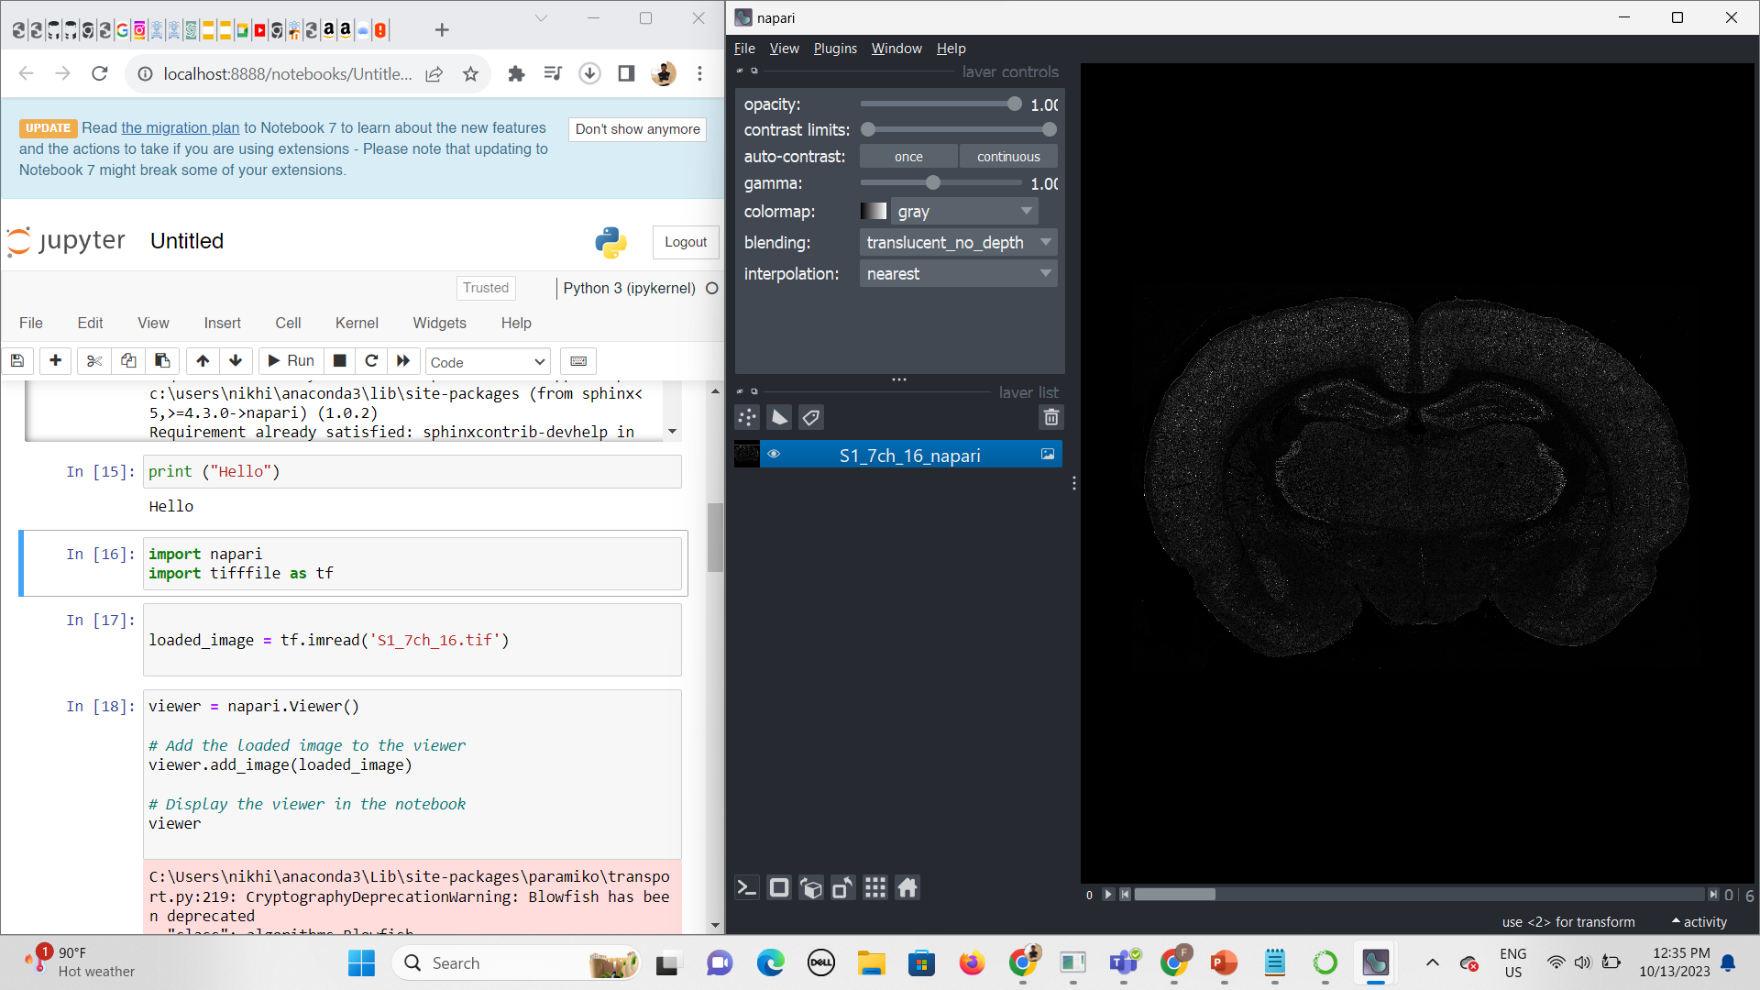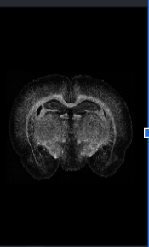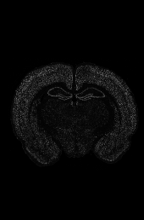
Fig 2.1 View of rat-brain tissue after staining with different biomarkers

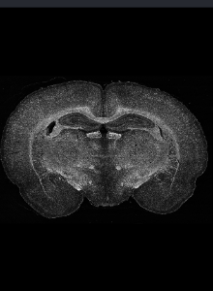
Fig 2.2 Combining and merging all the axes biomarker stains

- The file S1_7ch_16.tif is a detailed 16-bit image slice of a rat brain, referred to as "S1," with dimensions of 8611 x 5880 pixels and consisting of 7 channels.
- It can be viewed using napari, a versatile image viewer.
- The image includes limited expert-labeled data using biomarkers for specific regions and their surroundings, which are crucial for advanced analysis and model development in brain tissue research.

Code for conversion of 7 TIFF images into JPEG format :

# Convert each channel to a separate JPG image
for i in range(tif_data.shape[2]):
channel_data = tif_data[:, :, i]
# Normalize the data to 0-255 range
channel_data = (channel_data / channel_data.max()) * 255
# Convert to uint8
channel_data = channel_data.astype('uint8')
# Create PIL image
img = Image.fromarray(channel_data)
# Save as JPEG
img.save(os.path.join(jpg_dir, f"channel_{i}.jpg"))

3.2 Mask image

The file mask_s1.png is an 8611 x 5880 pixel, 10-class ground truth mask used for semantic segmentation. In this mask, pixel values range from 0 to 10, where 0 represents the background, and values from 1 to 10 correspond to different class labels. This detailed labeling is essential for accurate model training and validation in image segmentation tasks.

Code :

mask_path = r"mask_s1.png"

plt.imshow(mask_img, cmap='gray')
plt.title('Ground Truth Mask')
plt.axis('off')
plt.show()

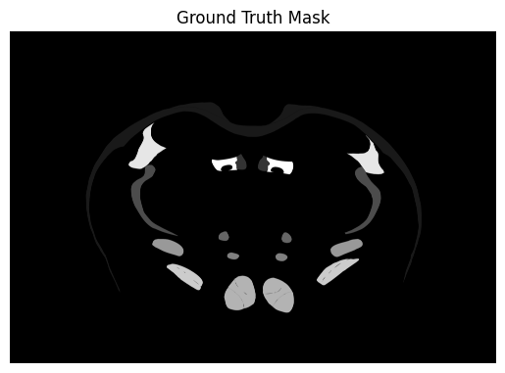
Fig 2.3 Ground Truth Mask

3.3 Performing Exploratory Data Analysis on mask image

We focus on the non-zero pixel values for performing EDA , as class 0 represents the background and is not of interest. This distribution provides insight into the prevalence and variation of the different classes within the mask.

# Basic statistics
mean_pixel_value = mask_df.values.mean()
min_pixel_value = mask_df.values.min()
max_pixel_value = mask_df.values.max()
std_dev_pixel_value = mask_df.values.std()

Mean Pixel Value: 0.28881627439037394
Min Pixel Value: 0
Max Pixel Value: 10
Standard Deviation of Pixel Values: 1.3786530110870578

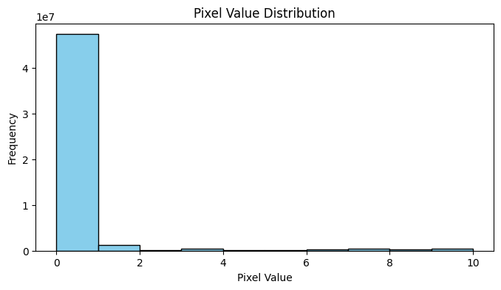
Fig 2.4 Pixel value distribution of data

# Annotate each bar with its frequency
for i, freq in enumerate(plt.hist(nonzero_pixel_values, bins=range(1, 12), color='skyblue', edgecolor='black')[0]):
plt.text(i + 1, freq, str(int(freq)), ha='left', va='bottom')
plt.show()

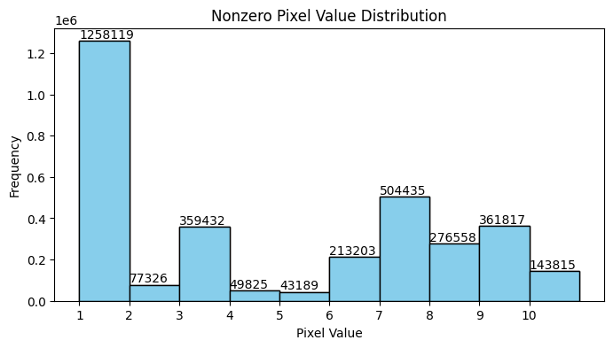
Fig 2.5 Non-zero pixel value distribution

Our analysis reveals that Class 1 occupies the largest region in the mask, indicating a significant imbalance. The class distribution is notably non-uniform, highlighting the varying prevalence of different classes within the dataset.

3.4 Data Visualisation

Utilizing visual representations to explore datasets

Code

for i in range(tif_data.shape[2]):
img = tif_data[:, :, i]
plt.imshow(img*10, cmap='gray')
plt.title(f'Channel {i}, Scaled 10x')
plt.axis('off')
plt.show()

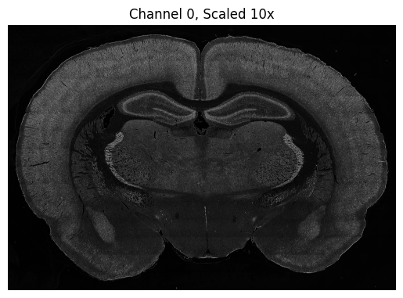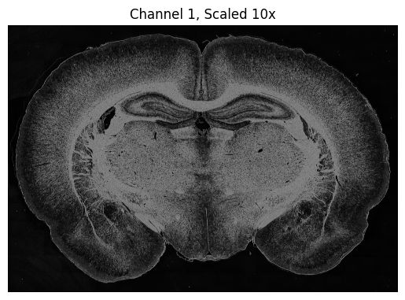
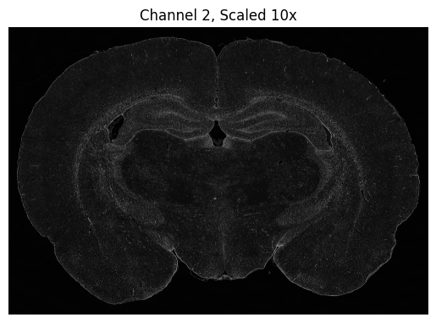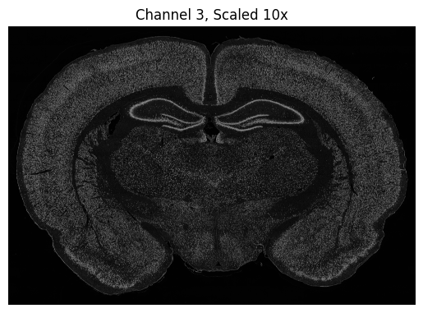
Fig 2.6 Data visualisation and exploration

3.5 Normalizing Pixel Values

Normalizing its pixel values for the 7 images , rounding them to the nearest integer, quantizing them to a range between 0 and 10 , converting them to unsigned 8-bit integers (uint8), and then calculating statistics .

import numpy as np

# Round normalized values to the nearest integer
img1_normalised_rounded = np.round(img1_normalised)

# Scale rounded values to the range [0, 10]
img1_quantized = (img1_normalised_rounded / 10) * 10

# Convert to integers between 0 and 10
img1_quantized = img1_quantized.astype('uint8')

# Calculate statistics
mean_pixel_value = np.mean(img1_quantized)
min_pixel_value = np.min(img1_quantized)
max_pixel_value = np.max(img1_quantized)
std_dev_pixel_value = np.std(img1_quantized)

print("Mean Pixel Value:", mean_pixel_value)
print("Min Pixel Value:", min_pixel_value)
print("Max Pixel Value:", max_pixel_value)
print("Standard Deviation of Pixel Values:", std_dev_pixel_value)

Mean Pixel Value: 0.03716358683759185
Min Pixel Value: 0
Max Pixel Value: 10
Standard Deviation of Pixel Values: 0.1943472516861053

3.6 Splitting the data into train and test :

- The brain sections are roughly symmetrical
- The training data for the Dino V2 model is formed from selected patches on the left half of the brain image
- The right half is reserved for testing the model’s performance

# Function to split image and mask into left and right halves
def split_image_and_mask(image, mask):
height, width = image.shape[:2]
half_width = width // 2
left_image = image[:, :half_width, :]
right_image = image[:, half_width:, :]
left_mask = mask[:, :half_width]
right_mask = mask[:, half_width:]
return left_image, right_image, left_mask, right_mask

# Path to directory containing images and mask
data_dir = r"../data/Brain_Data_S1_modified"
label_dir = os.path.join(data_dir, "labels")
image_dir = os.path.join(data_dir, "images")

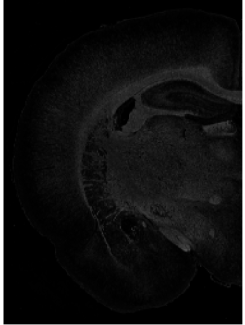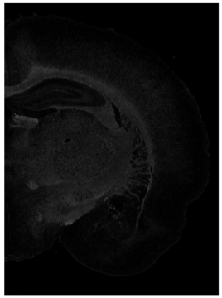
Fig 2.7 Train and test data

The dataset includes both test and train data, which are essential for evaluating the performance of our machine learning model and training it effectively. The train data will be used to teach the model to recognize patterns, while the test data will allow us to assess its accuracy and generalization capabilities on unseen data

Chapter : 4.Library Setup and Configuration

4.1 Significance of libraries and packages :

!pip install -q git+https://github.com/huggingface/transformers.git datasets
!pip install -q evaluate
!pip install accelerate
!pip show torch
!pip show torchvision
!pip show datasets
!pip show albumentations
pip install optuna

!pip install -q git+https://github.com/huggingface/transformers.git datasets:
- This command installs the transformers library from the specified GitHub repository. The -q flag is used to suppress output, making the installation process quieter.
- It also installs the datasets library, likely for handling datasets in the context of the research project.
!pip install -q evaluate:
- This command installs the evaluate package, which is likely a custom or project-specific package used for evaluation purposes.
!pip install accelerate:
- This command installs the accelerate package, which is used for speeding up PyTorch data loading and training.
!pip show torch, !pip show torchvision, !pip show datasets, !pip show albumentations:
- These commands show information about the installed versions of torch, torchvision, datasets, and albumentations packages, respectively. They don't actually install anything but display information about the installed packages.
pip install optuna:
- This command installs the optuna package, which is a hyperparameter optimization framework used in the research project.
Recent advancements in transformer models, such as the DINOv2 model from Hugging Face Transformers, have shown promising results in various segmentation tasks.
Python import statements that bring in specific functionality from various libraries :

import torch
import torch.nn as nn
import evaluate
import torch.optim as optim
from torch.optim import AdamW
from tqdm.auto import tqdm

Chapter : 5.Segmentation Map

5.1 Mapping every class to a random color

- Grayscale images and do not intrinsically leverage the rich multi-channel information provided by highly multiplexed IF microscopy imagery.

- The output will be a dictionary where each key is a class label (from 0 to num_classes - 1), and each value is an RGB color represented as a list of three integers (ranging from 0 to 255).

- The background class (label 0) will be mapped to black

# map every class to a random color
cmap = plt.cm.get_cmap('viridis') # Choose any colormap you prefer
num_classes = 11
colors = [cmap(i / num_classes) for i in range(num_classes)]
id2color = {i: [int(c * 255) for c in color[:3]] for i, color in enumerate(colors)}
id2color[0] = [0, 0, 0] # Setting background as black color
id2color
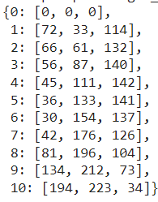

id2label assigns colors to different segmentation labels

# display the colors for each class with their class IDs
plt.figure(figsize=(10, 2))
for i, (class_id, color) in enumerate(id2color.items()):
plt.subplot(1, num_classes, i + 1)
plt.imshow([[color]])
plt.title(f"class {class_id}")
plt.axis("off")
plt.show()
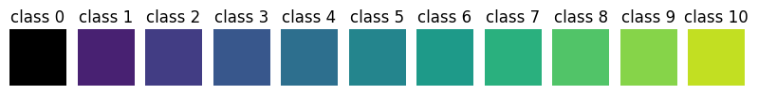
Fig 3.1 Colour associated with each class

We define a function called visualize_map that takes an image and a segmentation map created using id2label as input

5.2 Visualizing Segmentation Maps on Images :

The function visualize_map takes an image and a segmentation map, colors the segmentation map based on class labels, and overlays it on the image .

def visualize_map(image, segmentation_map):
color_seg = np.zeros((segmentation_map.shape[0], segmentation_map.shape[1], 3), dtype=np.uint8) # height, width, 3
for label, color in id2color.items():
color_seg[segmentation_map == label, :] = color

# Show image + mask
img = np.array(image) * 1 + color_seg * 0.5
img = img.astype(np.uint8)

plt.figure(figsize=(15, 10))
plt.imshow(img)
plt.axis('off')
plt.show()

visualize_map(image, segmentation_map)

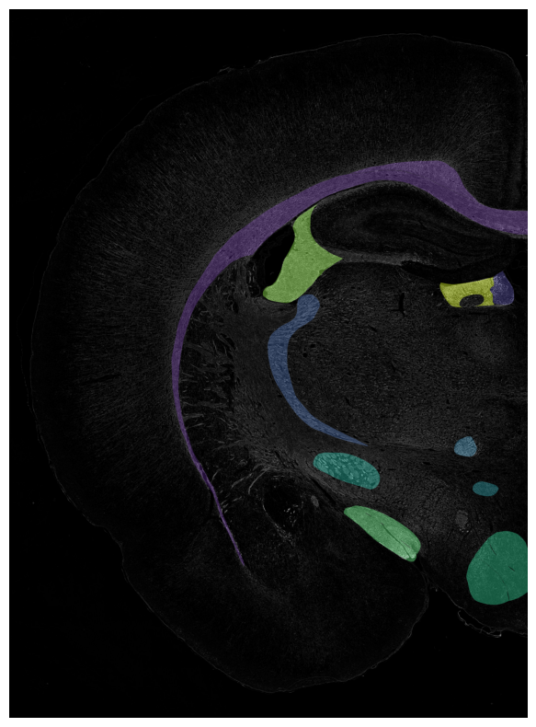
Fig 3.2 Ground Truth with assigned classes

This visualization helps in understanding how well the segmentation model performs by visually comparing the segmented regions with the original image.

Chapter : 6.MODEL

6.1 Creating Pytorch Dataset :

- This code defines a custom dataset class SegmentationDataset for a semantic segmentation task using PyTorch.
- The class inherits from torch.utils.data.Dataset, which is a base class for all datasets in PyTorch.
- The primary purpose of this class is to preprocess and provide images and their corresponding segmentation maps to a model during training or inference.

class SegmentationDataset(Dataset):
def __init__(self, dataset, transform):
self.dataset = dataset
self.transform = transform
def __len__(self):
return len(self.dataset)
def __getitem__(self, idx):
item = self.dataset[idx]
original_image = np.array(item["image"])
original_segmentation_map = np.array(item["label"])

transformed = self.transform(image=original_image, mask=original_segmentation_map)
image, target = torch.tensor(transformed['image']), torch.LongTensor(transformed['mask'])

# convert to C, H, W
image = image.permute(2,0,1)

return image, target, original_image, original_segmentation_map

6.2 Data Augmentation and Normalisation :

- This code snippet demonstrates setting up data augmentation and normalization for semantic segmentation using Albumentations.
- It defines mean and standard deviation values for normalization, then creates transformation pipelines for training and validation datasets.
- Training transformations include resizing, horizontal flipping, and normalization. Validation transformations only resize and normalize the images.

ADE_MEAN = np.array([123.675, 116.280, 103.530]) / 255
ADE_STD = np.array([58.395, 57.120, 57.375]) / 255
train_transform = A.Compose([
# hadded an issue with an image being too small to crop, PadIfNeeded didn't help...
# if anyone knows why this is happening I'm happy to read why
# A.PadIfNeeded(min_height=448, min_width=448),
# A.RandomResizedCrop(height=448, width=448),
A.Resize(width=448, height=448),
A.HorizontalFlip(p=0.5),
A.Normalize(mean=ADE_MEAN, std=ADE_STD),
], is_check_shapes=False)

val_transform = A.Compose([
A.Resize(width=448, height=448),
A.Normalize(mean=ADE_MEAN, std=ADE_STD),

], is_check_shapes=False)

train_dataset = SegmentationDataset(dataset_dict["train"], transform=train_transform)
val_dataset = SegmentationDataset(dataset_dict["validation"], transform=val_transform)

We are Resizing the test and validation images to 448x448 pixels.

- Next, we create Accelerate data loaders using the Accelerate library.
- These data loaders facilitate efficient data loading and batching, which is essential for training neural networks using stochastic gradient descent (SGD).
- The data loaders stack images and labels along a new batch dimension, optimizing the data pipeline for faster and more scalable training, especially in distributed or mixed-precision training setups.

# Wrap your dataloaders with Accelerator
train_dataloader = DataLoader(train_dataset, batch_size=3, shuffle=True, collate_fn=collate_fn)
train_dataloader = accelerator.prepare(train_dataloader)

val_dataloader = DataLoader(val_dataset, batch_size=3, shuffle=False, collate_fn=collate_fn)
val_dataloader = accelerator.prepare(val_dataloader)

6.3 Dino v2 As Encoder :

- Dinov2Model and Dinov2PreTrainedModel are classes from the transformers library for the DINOv2 model.
- SemanticSegmenterOutput is a standardized output class for semantic segmentation models.

from transformers import Dinov2Model, Dinov2PreTrainedModel
from transformers.modeling_outputs import SemanticSegmenterOutput

- This code defines a custom semantic segmentation model using the DINOv2 architecture as an encoder.
- The decoder consists of linear classifiers and 2-D convolutional layers to generate segmentation maps.
- The forward method processes the input through the encoder, reshapes the embeddings, applies the decoder, resizes the logits, computes the loss if labels are provided, and returns the output in a standardized format.
- The model is then initialized with pre-trained weights, ready for fine-tuning or evaluation.

class Dinov2ForSemanticSegmentation(Dinov2PreTrainedModel):
def __init__(self, config, num_labels=11, **kwargs):
super().__init__(config)
self.dinov2 = Dinov2Model(config)
self.decoder = DeconvDecoder(config.hidden_size, num_labels)

def forward(self, pixel_values, output_hidden_states=False, output_attentions=False, labels=None):
outputs = self.dinov2(pixel_values, output_hidden_states=output_hidden_states, output_attentions=output_attentions)
patch_embeddings = outputs.last_hidden_state[:, 1:, :] # Exclude CLS token
logits = self.decoder(patch_embeddings)

logits = torch.nn.functional.interpolate(logits, size=pixel_values.shape[2:], mode="bilinear", align_corners=False)

loss = None
if labels is not None:
assert torch.max(labels) < logits.shape[1], f"Max label {torch.max(labels)} is greater than the number of classes {logits.shape[1]}"
loss_fct = torch.nn.CrossEntropyLoss(ignore_index=0)
loss = loss_fct(logits, labels)

return SemanticSegmenterOutput(
loss=loss,
logits=logits,
hidden_states=outputs.hidden_states,
attentions=outputs.attentions,
)

The model is then initialized with pre-trained weights

model = Dinov2ForSemanticSegmentation.from_pretrained("facebook/dinov2-base", id2label=id2label, num_labels=len(id2label))

6.4 Verifying Model Output and Loss Computation :

Code runs a forward pass through a model with given inputs and labels, then prints the shape of the model's output logits and the computed loss value. This is useful for verifying that the model's outputs have the correct shape and that the loss is being computed as expected

outputs = model(pixel_values=pixel_values, labels=labels)
print(outputs.logits.shape)
print(outputs.loss)

torch.Size([3, 11, 448, 448])
tensor(2.3979, grad_fn=<NllLoss2DBackward0>)

This code determines whether a GPU is available and, if so, to move the model to the GPU for faster computation

device = "cuda" if torch.cuda.is_available() else "cpu"
print("Using device:", device)
model.to(device)

6.5 Training the Model
- Hyperparameter optimization is conducted using Optuna, where the objective function suggests learning_rate and weight_decay within specified ranges.
- The AdamW optimizer is initialized with these suggested hyperparameters, along with the WarmupCosineSchedule and MomentumSchedule. The training loop comprises several epochs, during which the model is set to training mode.
- In the validation phase, predictions are made and stored without gradient calculations. The training phase involves looping through the training data, zeroing gradients, performing forward passes, calculating and backpropagating loss, updating weights, and adjusting the learning rate.
- Metrics such as IoU and accuracy for both binary and multi-class segmentation are computed and printed for each epoch and class to monitor performance.
- Early stopping is employed by comparing the current mean_iou with the best_mean_iou, saving the best model state if there is an improvement, and stopping training if no improvement is observed for a set number of epochs (early_stopping_patience).
- An Optuna study is created to maximize mean_iou, running for a specified number of trials (n_trials=3). The best trial's details are printed, and the final training is conducted with the best hyperparameters.
- The AdamW optimizer, WarmupCosineSchedule, and MomentumSchedule are reinitialized with these parameters, and the best model state is loaded to ensure optimal performance.

Chapter : 7.Approach
We have implemented three approaches to enhance segmentation accuracy and improve metrics. For two of these strategies, we utilized a dataset consisting of seven images for both training and testing, created using biomarkers. For the third strategy, we concentrated on a dataset containing cropped images.

7.1 Training Model With 7 Biomarkers

7.1.1 Linear Classifier as Decoder :

A linear classifier as a decoder in semantic segmentation is a simplified approach where the output of the encoder is directly fed into a linear classifier to predict the class label for each pixel in the input image.This approach is a basic form of semantic segmentation and is computationally less expensive compared to more complex decoder architectures like transposed convolutions or fully convolutional networks .

In a linear classifier decoder, the output of the encoder (often a feature map) is flattened into a vector and fed into a fully connected layer (linear classifier). This fully connected layer performs a linear transformation on the flattened feature vector to predict the class label for each pixel.

class LinearClassifier(torch.nn.Module):
def __init__(self, in_channels, tokenW=32, tokenH=32, num_labels=1):
super(LinearClassifier, self).__init__()

self.in_channels = in_channels
self.width = tokenW
self.height = tokenH
self.classifier = torch.nn.Conv2d(in_channels, num_labels, (1,1))

def forward(self, embeddings):
embeddings = embeddings.reshape(-1, self.height, self.width, self.in_channels)
embeddings = embeddings.permute(0,3,1,2)

return self.classifier(embeddings)

7.1.1.1 Training the model with larger number of epochs:

Training the model for more epochs can improve segmentation accuracy by allowing the model to learn more from the data. However, it's important to monitor for overfitting and adjust the learning rate schedule accordingly.

# Function to compute validation loss
def compute_validation_loss(model, val_dataloader, device):
model.eval()
val_loss = 0
with torch.no_grad():
for batch in val_dataloader:
pixel_values = batch["pixel_values"].to(device)
labels = batch["labels"].to(device)
outputs = model(pixel_values, labels=labels)
val_loss += outputs.loss.item()
return val_loss / len(val_dataloader)

# Put model in training mode
model.train()

for epoch in range(max_epochs):
print("Epoch:", epoch)
for idx, batch in enumerate(tqdm(train_dataloader)):
pixel_values = batch["pixel_values"].to(device)
labels = batch["labels"].to(device)

# Forward pass
outputs = model(pixel_values, labels=labels)
loss = outputs.loss

# Print shapes
print("Logits shape:", outputs.logits.shape)
print("Labels shape:", labels.shape)

loss.backward()
optimizer.step()

# Zero the parameter gradients
optimizer.zero_grad()

# Evaluate
with torch.no_grad():
predicted = outputs.logits.argmax(dim=1)

# Note that the metric expects predictions + labels as numpy arrays
metric.add_batch(predictions=predicted.detach().cpu().numpy(), references=labels.detach().cpu().numpy())

# Let's print loss and metrics every batch
if idx % 1 == 0:
metrics = metric.compute(num_labels=len(id2label),
ignore_index=0,
reduce_labels=False)
print("idx:", idx)
print("Loss:", loss.item())
print("Mean_iou:", metrics["mean_iou"])
print("Mean accuracy:", metrics["mean_accuracy"])
print("------------------------------------------")

# Validation loss computation
val_loss = compute_validation_loss(model, val_dataloader, device)
print(f"Validation Loss: {val_loss}")

# Early stopping check
if val_loss < best_val_loss - min_delta:
best_val_loss = val_loss
epochs_no_improve = 0
else:
epochs_no_improve += 1
if epochs_no_improve >= patience:
print(f"Early stopping at epoch {epoch}")
break

Increasing number of epochs will improve the metric IOU for each class
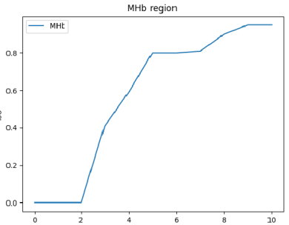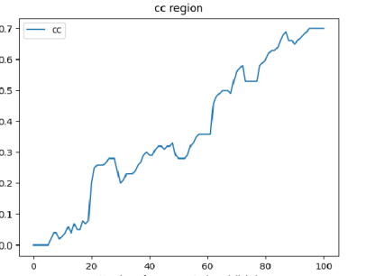
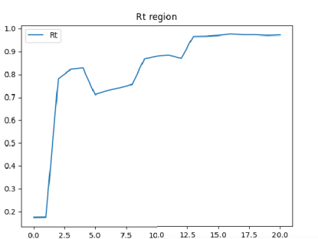
Fig 4.1 IoU vs number of epochs for each brain region

7.1.1.2 Fine Tuning Hyperparameters :

Local fine-tuning of the multi-class model has shown to improve segmentation quality.
We are currently optimizing two hyperparameters:
- Learning Rate: This parameter controls the step size in optimization, helping adjust model parameters to minimize loss.
- Weight Decay: Used for regularization, it penalizes large weights to prevent overfitting.
Both hyperparameters are adjusted using cosine learning rate and momentum schedulers to enhance model training efficiency.
Hyperparameter Optimization with Optuna:
- objective: Defines the objective function for Optuna to optimize.
- Suggests learning_rate and weight_decay within specified ranges.
- Initializes AdamW optimizer with suggested hyperparameters.
- Initializes WarmupCosineSchedule and MomentumSchedule.
We prefer using the Accelerate library in PyTorch. It helps speed up data loading and preprocessing by leveraging hardware accelerators, enhancing overall training performance.

def calculate_metrics(predictions, references):
intersection = torch.logical_and(predictions, references).sum().item()
union = torch.logical_or(predictions, references).sum().item()
mean_iou = intersection / union
accuracy = (predictions == references).float().mean().item()
return mean_iou, accuracy

def objective(trial):
learning_rate = trial.suggest_loguniform("learning_rate", 1e-4, 1e-1)
momentum = trial.suggest_uniform("momentum", 0.9, 0.999)
weight_decay = trial.suggest_loguniform("weight_decay", 1e-5, 1e-3)

optimizer = torch.optim.SGD(model.parameters(), lr=learning_rate, momentum=momentum, weight_decay=weight_decay)
scaler = torch.cuda.amp.GradScaler() # For mixed precision training

num_epochs = trial.suggest_int("num_epochs", 5, 50)
patience = 3
best_val_loss = float('inf')
counter = 0

for epoch in range(num_epochs):
model.train()
for idx, batch in enumerate(tqdm(train_dataloader, desc=f"Epoch {epoch+1}")):
pixel_values = batch["pixel_values"].to(device, non_blocking=True)
labels = batch["labels"].to(device, non_blocking=True)
original_images = batch["original_images"]
original_segmentation_maps = batch["original_segmentation_maps"]

optimizer.zero_grad()
with torch.cuda.amp.autocast(): # Mixed precision context
outputs = model(pixel_values, labels=labels)
loss = outputs.loss

scaler.scale(loss).backward()
scaler.step(optimizer)
scaler.update()

if idx % 100 == 0: # Reduce frequency of printing
with torch.no_grad():
predicted = outputs.logits.argmax(dim=1)
metric.add_batch(predictions=predicted.detach().cpu().numpy(), references=labels.detach().cpu().numpy())
metrics = metric.compute(num_labels=len(id2label), ignore_index=0, reduce_labels=False)

print(f"Epoch: {epoch}, Batch: {idx}, Loss: {loss.item()}, Mean IoU: {metrics['mean_iou']}, Mean Accuracy: {metrics['mean_accuracy']}")

model.eval()
val_loss = 0.0
with torch.no_grad():
for batch in val_dataloader:
pixel_values = batch['pixel_values'].to(device, non_blocking=True)
labels = batch['labels'].to(device, non_blocking=True)
original_images = batch['original_images']
original_segmentation_maps = batch['original_segmentation_maps']

outputs = model(pixel_values, labels=labels)
loss = outputs.loss

val_loss += loss.item()

val_loss /= len(val_dataloader)

print(f"Epoch {epoch+1}, Validation Loss: {val_loss}")

if val_loss < best_val_loss:
best_val_loss = val_loss
counter = 0
else:
counter += 1
if counter >= patience:
print(f"Early stopping at epoch {epoch+1} with best validation loss: {best_val_loss}")
break

return best_val_loss
# Create a study object and optimize the objective function
study = optuna.create_study(direction="minimize")
study.optimize(objective, n_trials=5)

# Get the best hyperparameters
best_params = study.best_params
print("Best hyperparameters:", best_params)

7.1.2 Implementation of 2D convolutional layers as decoder :
We have implemented the DeconvDecoder class, which describes the deconvolutional decoder architecture. This decoder uses transposed 2D convolutional layers to upsample input embeddings to the original image size.
We chose 2D convolutional layers for several reasons:
- Extracting Spatial Features: 2D convolutional layers are adept at extracting spatial features from the input data, which is crucial for semantic segmentation. These features help the model understand the spatial layout of objects in the image.
- Capturing Contextual Information: By applying convolutional operations across the image, 2D convolutional layers can capture contextual information, allowing the model to consider the surrounding pixels when making predictions. This context helps in distinguishing between objects and their surroundings.
- Non-linearities: 2D convolutional layers apply non-linear activation functions (such as ReLU) to their output, enabling the model to learn complex patterns and relationships in the data. This non-linearity is essential for segmenting complex visual data.
- Segmenting Complex Visual Data: The ability of 2D convolutional layers to capture spatial features, contextual information, and apply non-linearities makes them well-suited for segmenting complex visual data. This includes scenarios where objects exhibit intricate shapes or textures, as the model can learn to distinguish between these features effectively.

class DeconvDecoder(nn.Module):
def __init__(self, in_channels, out_channels):
super(DeconvDecoder, self).__init__()
self.decoder = nn.Sequential(
nn.ConvTranspose2d(in_channels, 256, kernel_size=4, stride=2, padding=1),
nn.ReLU(),
nn.ConvTranspose2d(256, 128, kernel_size=4, stride=2, padding=1),
nn.ReLU(),
nn.ConvTranspose2d(128, out_channels, kernel_size=4, stride=2, padding=1)
)

def forward(self, embeddings):
B, N, C = embeddings.shape
H = W = int(N**0.5)
if H * W != N:
raise ValueError("The number of patches is not a perfect square")
embeddings = embeddings.permute(0, 2, 1).reshape(B, C, H, W)
return self.decoder(embeddings)

7.2 Cropping Images Dataset

- Another approach we employed involved creating a dataset comprising all 448 x 448 sized crops of each image and its corresponding ground truth, resulting in approximately 800 images.
- However, we filtered out images whose masks consisted only of the background class and no other class.
- This refinement led to an effective dataset of around 200 images, ensuring that the dataset was more focused on meaningful segmentation tasks.

# Training and Validation Code
def crop_and_save_images(images_path, labels_path, save_images_path, save_labels_path):
# Check if directories already exist
if os.path.exists(save_images_path) and os.path.exists(save_labels_path):
print(f"Directories {save_images_path} and {save_labels_path} already exist")
return
else:
os.makedirs(save_images_path, exist_ok=True)
os.makedirs(save_labels_path, exist_ok=True)

# Get list of image files
image_files = sorted(os.listdir(images_path))
label_files = sorted(os.listdir(labels_path))

print(f"Found {len(image_files)} image files and {len(label_files)} label files")

for image_file, label_file in zip(image_files, label_files):
# Read images
image_path = os.path.join(images_path, image_file)
label_path = os.path.join(labels_path, label_file)
print(f"Processing {image_path} and {label_path}")

image = cv2.imread(image_path, cv2.IMREAD_UNCHANGED)
label = cv2.imread(label_path, cv2.IMREAD_UNCHANGED)

if image is None:
print(f"Error reading image file: {image_path}")
continue
if label is None:
print(f"Error reading label file: {label_path}")
continue

# Get dimensions
height, width = image.shape[:2]
crop_size = 448 # Adjust crop size as needed

print(f"Image dimensions (height, width): ({height}, {width})")

# Calculate number of crops
num_vertical = height // crop_size
num_horizontal = width // crop_size

print(f"Number of vertical crops: {num_vertical}, number of horizontal crops: {num_horizontal}")

# Crop and save
for i in range(num_vertical):
for j in range(num_horizontal):
crop_image = image[i*crop_size:(i+1)*crop_size, j*crop_size:(j+1)*crop_size]
crop_label = label[i*crop_size:(i+1)*crop_size, j*crop_size:(j+1)*crop_size]

crop_image_filename = os.path.join(save_images_path, f"{image_file[:-4]}_{i}_{j}.png")
crop_label_filename = os.path.join(save_labels_path, f"{label_file[:-4]}_{i}_{j}.png")

cv2.imwrite(crop_image_filename, crop_image)
cv2.imwrite(crop_label_filename, crop_label)

print(f"Saved cropped image: {crop_image_filename}")
print(f"Saved cropped label: {crop_label_filename}")

Image Label
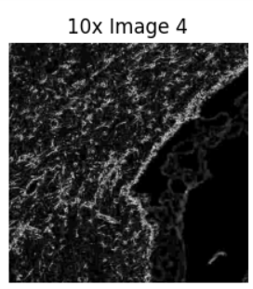
Fig 4.2 Cropping images dataset

Code for Training :
max_epochs = 10 # Set a high upper limit for epochs
# Early stopping parameters
patience = 5 # Number of epochs to wait for improvement
min_delta = 0.001 # Minimum change to qualify as an improvement
best_val_loss = np.inf
epochs_no_improve = 0
# Function to compute validation loss
def compute_validation_loss(model, val_dataloader, device):
model.eval()
val_loss = 0
with torch.no_grad():
for batch in val_dataloader:
pixel_values = batch["pixel_values"].to(device)
labels = batch["labels"].to(device)
outputs = model(pixel_values, labels=labels)
val_loss += outputs.loss.item()
return val_loss / len(val_dataloader)
# Put model in training mode
model.train()
for epoch in range(max_epochs):
print("Epoch:", epoch)
for idx, batch in enumerate(tqdm(train_dataloader)):
pixel_values = batch["pixel_values"].to(device)
labels = batch["labels"].to(device)

# Forward pass
outputs = model(pixel_values, labels=labels)
loss = outputs.loss
# Print shapes
print("Logits shape:", outputs.logits.shape)
print("Labels shape:", labels.shape)

loss.backward()
optimizer.step()
# Zero the parameter gradients
optimizer.zero_grad()

# Evaluate
with torch.no_grad():
predicted = outputs.logits.argmax(dim=1)

# Note that the metric expects predictions + labels as numpy arrays
metric.add_batch(predictions=predicted.detach().cpu().numpy(), references=labels.detach().cpu().numpy())

# Let's print loss and metrics every batch
if idx % 1 == 0:
metrics = metric.compute(num_labels=len(id2label),
ignore_index=0,
reduce_labels=False)
print("idx:", idx)
print("Loss:", loss.item())
print("Mean_iou:", metrics["mean_iou"])
print("Mean accuracy:", metrics["mean_accuracy"])
print("------------------------------------------")

# Validation loss computation
val_loss = compute_validation_loss(model, val_dataloader, device)
print(f"Validation Loss: {val_loss}")

# Early stopping check
if val_loss < best_val_loss - min_delta:
best_val_loss = val_loss
epochs_no_improve = 0
else:
epochs_no_improve += 1
if epochs_no_improve >= patience:
print(f"Early stopping at epoch {epoch}")
break

7.3 Binary and Multi-Class Classification Combined

- An underperforming class is selected, and it’s region is isolated from the rest of the image.
- We then re-frame the segmentation as a binary problem rather than multi-class, considering only the class of interest and the background of the sub-region .
- The result of this approach is a set of binary fine-tuned models for every class in the dataset.
- We achieve better segmentation performance with these models than could have been hoped for with a multi-class model, and have done so with a minimal amount of labelling effort during testing/deployment.

def objective(trial):
learning_rate = trial.suggest_loguniform("learning_rate", 0.00887, 0.1)
weight_decay = trial.suggest_loguniform("weight_decay", 1e-5, 1e-3)

optimizer = AdamW(model.parameters(), lr=learning_rate, weight_decay=weight_decay)
total_steps = 4000 # Reduced from 625000
warmup_steps = 800 # Reduced from 100000
lr_scheduler = WarmupCosineSchedule(optimizer, warmup_steps, total_steps, min_lr=0.04, max_lr=0.2)
momentum_scheduler = MomentumSchedule(0.994, 1.0, total_steps)

epochs = 8 # Further reduced the number of epochs for faster tuning
early_stopping_patience = 2 # Reduced the patience for early stopping for faster tuning
best_mean_iou = -1
best_model_state_dict = None
early_stopping_counter = 0

for epoch in range(epochs):
total_loss = 0
model.train()
predictions = []
true_labels = []
with torch.no_grad():
for val_batch in val_dataloader:
val_pixel_values = val_batch["pixel_values"].to(device)
val_labels = val_batch["labels"].to(device)
val_outputs = model(val_pixel_values, labels=val_labels)
predictions.extend(torch.argmax(val_outputs.logits, dim=1).cpu().numpy())
true_labels.extend(val_labels.cpu().numpy())

for idx, batch in enumerate(tqdm(train_dataloader)):
pixel_values = batch["pixel_values"].to(device)
labels = batch["labels"].to(device)

optimizer.zero_grad()
outputs = model(pixel_values, labels=labels)
loss = outputs.loss

loss.backward()
optimizer.step()
lr_scheduler.step()

total_loss += loss.item()

total_loss /= len(train_dataloader)

metrics = compute_metrics(predictions, true_labels, num_labels=len(id2color))
binary_iou = metrics["binary_iou"]
binary_accuracy = metrics["binary_accuracy"]
mean_iou = metrics["mean_iou"]
mean_accuracy = metrics["mean_accuracy"]
per_class_iou_list = metrics["per_class_iou_list"]
per_class_accuracy_list = metrics["per_class_accuracy_list"]

Chapter : 8.Analysis and Results

Code for visualisation :

visualize_map(test_image, predicted_map.squeeze().cpu())

8.1 Training Model With 7 Biomarkers

8.1.1 Using Linear classifier as decoder

8.1.1.1 Training the model with larger number of epochs :
- Monitoring validation loss prevents overfitting; early stopping is effective.
- Visualization improved, but no significant change between epochs 23 and 40.
- Minimizing validation loss with early stopping for fewer epochs is accurate.

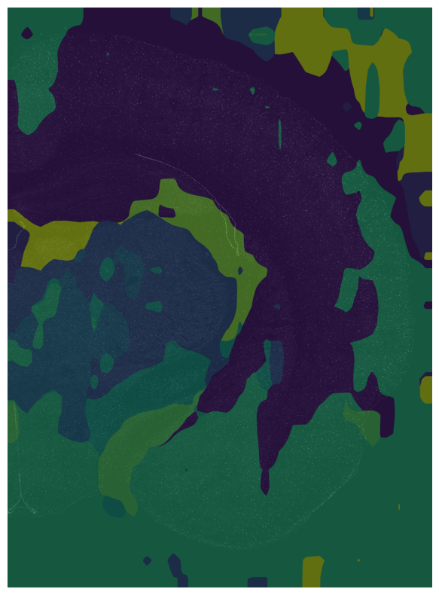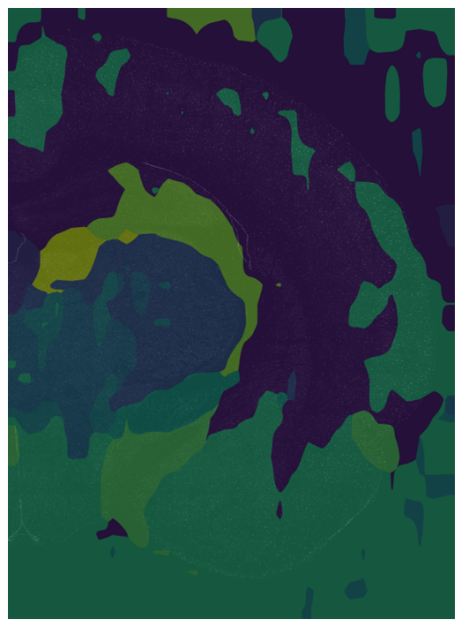

Fig 5.1 Visualisation after training model respectively for 5 and 40 epochs

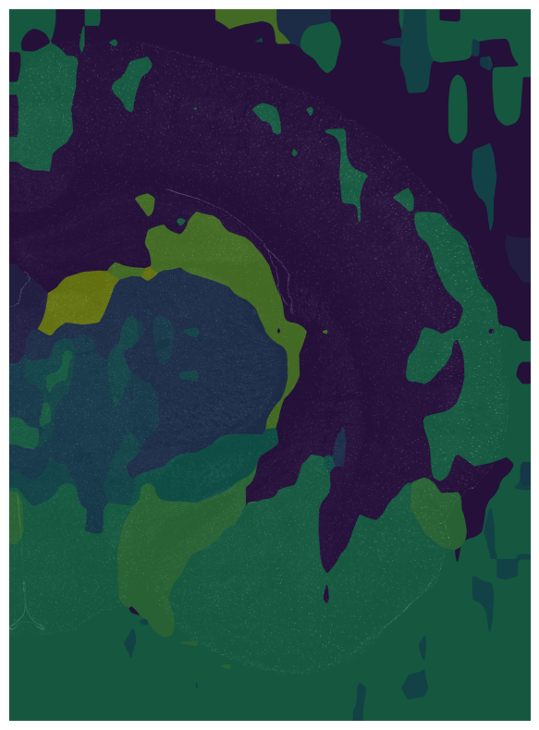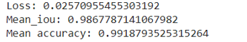

Fig 5.2 Visualisation for 23 epochs with early stopping and its metrics

8.1.2 Fine Tuning Hyperparameters :

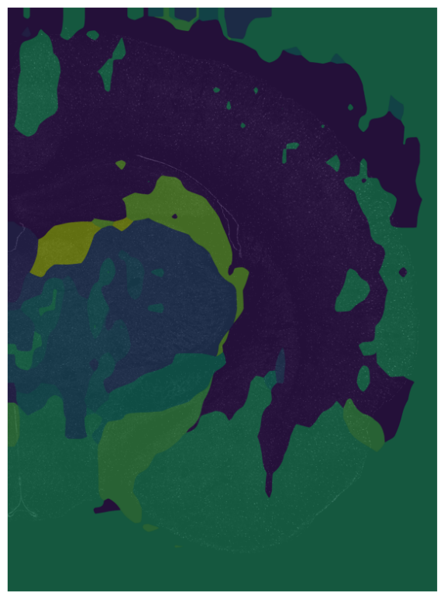

Fig 5.3 Visualisation after 2 trials after implementation of hyperparameter tuning

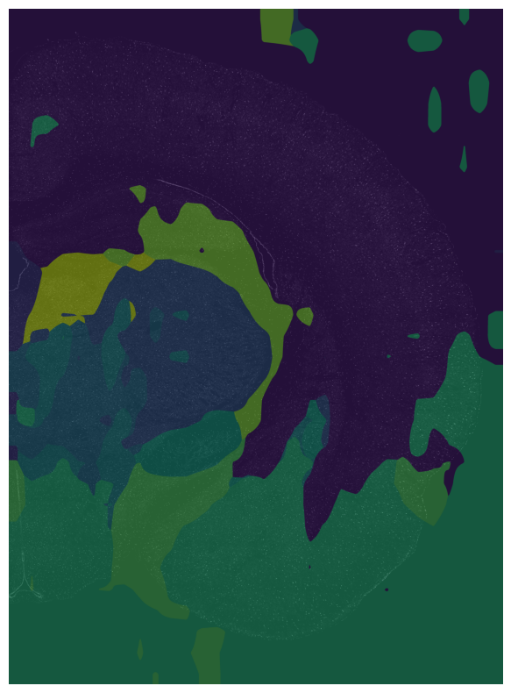

Fig 5.4 Visualisation After 5 trials at epoch 19 after implementation of hyperparameter tuning

- Parameters: {'learning rate': 0.0074320120, 'weight decay': 0.00025593}
- Epoch: 10, Loss: 0.00580, Mean IoU: 0.7450, Mean Accuracy: 0.8376
The hyperparameter-tuned model might generalize better to new, unseen data as observed from visualisation, even if its performance on the training set is slightly lower as seen from metrics

8.2 Implementation of 2D convolutional layers as decoder

The utilization of 2D convolutional layers as decoder has led to a slight improvement in metrics and a reduction in loss indicating better performance
Visualisation :

Metrics :
Loss : 0.0027
Mean IOU : 0.7531
Mean Accuracy : 0.8486

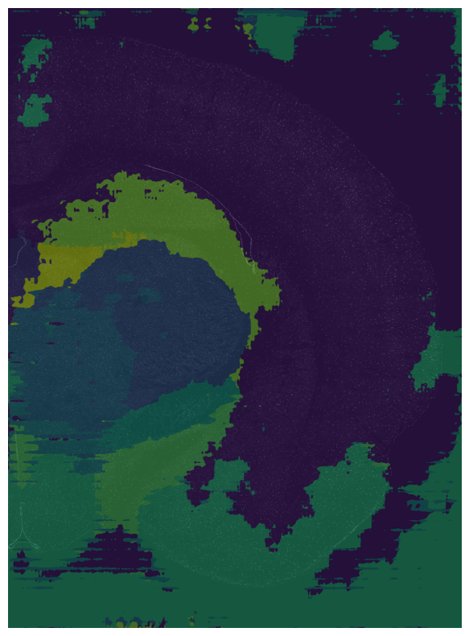
Fig 5.5 Visualisation after implementation of 2-D convolutional layers as decoder

8.2 Cropping images dataset

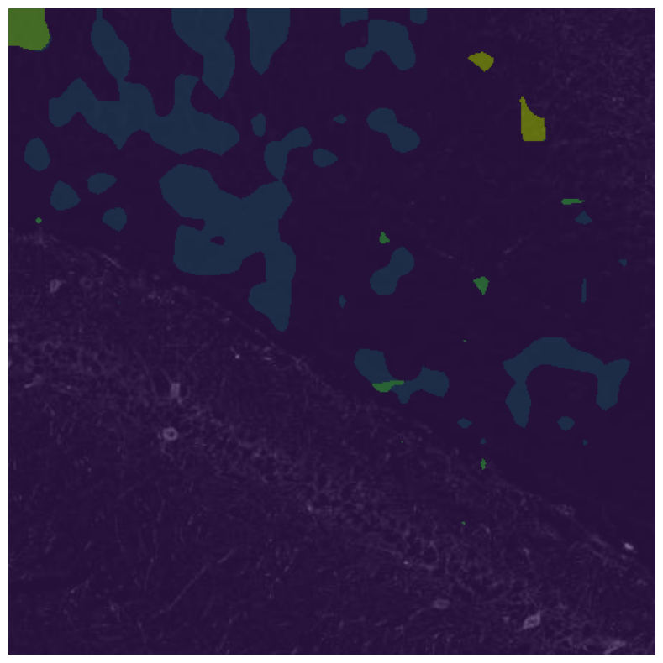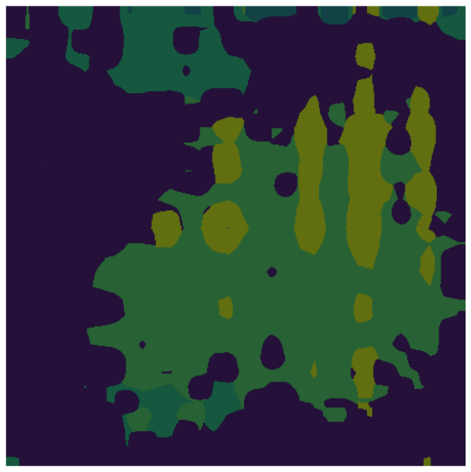
Fig 5.6 Visualisation after training cropping images for respectively for 2 and 5 epochs

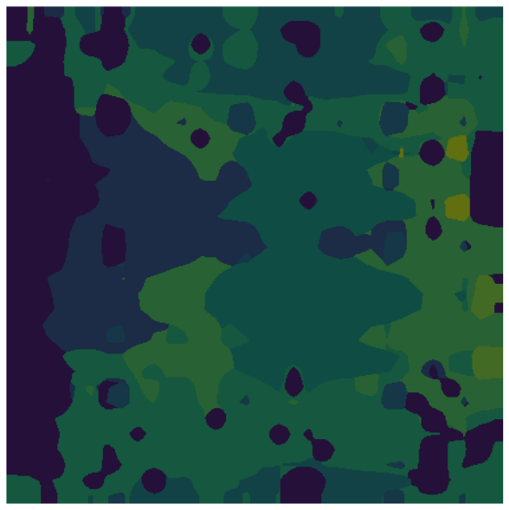
Fig 5.7 Visualisation after training cropping images for higher number of epochs

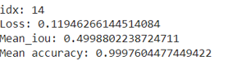

Fig 5.8 Metrics for final visualization

- The data shows NaN loss in multi-class classification for image cropping, making the conclusions unreliable.
- Mean IoU is also extremely low, indicating difficulties in accurate image segmentation. So this approach is discarded

8.3 Binary and Multi-Class Classification Combined

- The per-class metrics have improved using this method compared to previous approaches and the results from previous research work.
- This approach effectively segments the classes

Overall Metrics :

Epoch : 7
Loss : 0.0773
Mean IOU (Multi class) : 0.7225
Accuracy (Multi class) : 0.8114
Mean IOU (Binary class) : 0.092
Accuracy (Binary class) : 0.8114

Metrics for each class resulting from integration of binary classification in multi-classification :

Class 1 : IOU : 0.9349 , Accuracy : 0.9964
Class 2 : IOU : 0.6085 , Accuracy : 0.7602
Class 3 : IOU : 0.7455 , Accuracy : 0.9399
Class 4 : IOU : 0.8105 , Accuracy : 0.9749
Class 5 : IOU : 0.1858 , Accuracy : 0.1991
Class 6 : IOU : 0.6546, Accuracy : 0.8240
Class 7 : IOU : 0.9138 , Accuracy : 0.9595
Class 8 : IOU : 0.8032 , Accuracy : 0.8523
Class 9 : IOU : 0.6417, Accuracy : 0.6669
Class 10 : IOU : 0.7084, Accuracy : 0.7537

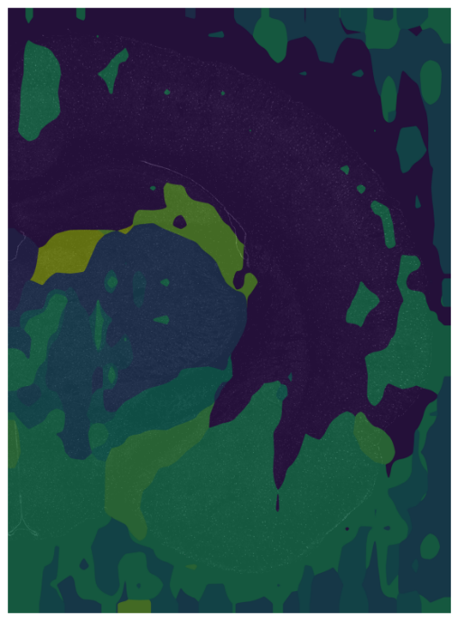
Fig 5.9 Visualisation after integrating multiple and binary approach

- Type 1 regions include MHb, Rt, and sm. These regions were segmented well by the multi-class model, so local fine-tuning yielded little or no improvement.
- Type 2 regions include MGP, VMH, opt, and fi. All of these regions saw major improvement from incremental learning.
- Type 3 regions include mt and Stg. Both of these very small regions saw large improvements from incremental learning. cc is a particular region of interest, because it’s inference region practically spans the entire image.

One might expect a large amount of false-positive segmentations due to having so many different regions in the same domain, but binary fine-tuned model is able to identify the region of interest .

Chapter : 9.Conclusions

9.1 Comparison of Metrics

The results achieved with our methods, particularly approaches 1 and 3, show significant improvements compared to those reported in the research paper

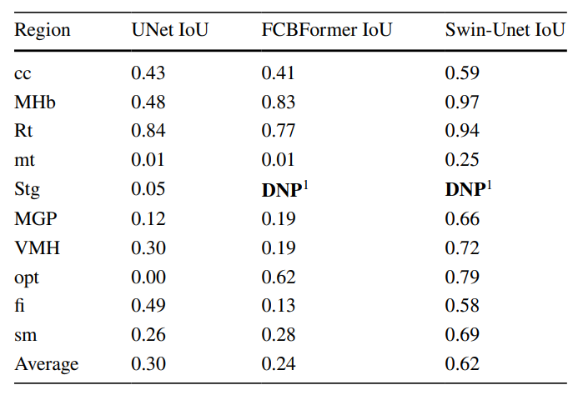
Table 1.1 IOU for 10 classes implementing different models from research paper

 | Mean _iou | Accuracy | Loss
Metrics from research paper | 0.620
Approach 1 :  Using Linear classifier | 0.745 | 0.83 | 0. 005
Approach 1 :  Using 2-D convolutional layers | 0.753 | 0.85 | 0.002
Cropping Images : | 0.498 | 0.9976 | 0.119
Binary Classification Integrated: | 0.9349 | 0.8114 | 0.007

Table 1.2 Performance metrics for all implemented approaches
9.2 Insights

- Improved Segmentation for 8 out of 10 Regions: Our model showed significant improvement in segmenting 8 out of 10 regions, indicating its effectiveness in handling diverse segmentation tasks.
- Improved Intersection over Union Metric: The average Intersection over Union (IoU) metric improved, showcasing the model's overall better performance in accurately delineating object boundaries.
- Appropriate Pre-training for Efficient Adaptation: Starting with appropriate pre-training, our framework efficiently adapted the model to diverse images and regions within an image. This adaptation required minimal user input for additional labeling, highlighting the model's ability to generalize well.
- Epochs Impact on Metrics: Metrics for each class showed improvement with more epochs, indicating the importance of training duration in achieving better segmentation results.
- Hyperparameter Fine-Tuning: Fine-tuning hyperparameters yielded better results, underlining the significance of hyperparameter optimization in enhancing model performance.
- Local Fine-Tuning for Multi-Class Model: Local fine-tuning of the multi-class model further enhanced segmentations, demonstrating the effectiveness of targeted adjustments.
- Complex Decoder for Improved Quality: Implementing a complex decoder with DINOv2 reduced loss and improved segmentation quality, as visually evident from the results. This highlights the importance of model architecture in achieving better segmentation outcomes.
- Ineffectiveness of Image Cropping: Image cropping was found to be ineffective as it did not improve mean IoU and resulted in higher loss. This suggests that alternative approaches may be more suitable for enhancing segmentation performance.
- Effective Segmentation for Invisible Regions: The third approach effectively segmented regions that are not visible to the human eye and cannot be distinguished from surrounding regions. This demonstrates the model's capability to handle challenging segmentation tasks.
- Valuable Insights into Brain Function: By providing detailed maps and profiles of brain regions, this method offers valuable insights into brain function and pathology. This facilitates a deeper understanding of neurological conditions and their treatments, showcasing the potential impact of our approach in the field of neuroscience.

References

- Maric D, Jahanipour J, Li XR, Singh A, Mobiny A, Van Nguyen H, Sedlock A, Grama K, Roysam B. Whole-brain tissue mapping toolkit using large-scale highly multiplexed immunofluorescence imaging and deep neural networks. Nat Commun. 2021 Mar 10;12(1):1550. doi: 10.1038/s41467-021-21735-x. PMID: 33692351; PMCID: PMC7946933.s
- https://colab.research.google.com/drive/1Hl1i_I70WTVTbs-zU_NZNYIZ6B_TsAQv?usp=sharing
- https://github.com/facebookresearch/dinov2
- https://huggingface.co/docs/transformers/main/en/model_doc/dinov2
- https://arxiv.org/pdf/2304.07193
- https://pubmed.ncbi.nlm.nih.gov/38234728/
- https://figshare.com/articles/dataset/Whole-brain_tissue_mapping_toolkit_using_large-scale_highly_multiplexed_immunofluorescence_imaging_and_deep_neural_networks_Data_/13731585/1
- https://figshare.com/articles/dataset/Whole-brain_tissue_mapping_toolkit_using_large-scale_highly_multiplexed_immunofluorescence_imaging_and_deep_neural_networks_Data_/137315

- Azad, R., Aghdam, E. K., Rauland, A., Jia, Y., Avval, A. H., Bozorgpour, A., Karimijafarbigloo, S., Cohen, J. P., Adeli, E., & Merhof, D. (2022). Medical image segmentation review: the success of U-Net. arXiv. arXiv:2211.14830 [cs, eess]. http://arxiv.org/abs/2211.14830. Accessed September 6, 2023. Beucher, S. (1992).

- The watershed transformation applied to image segmentation. Caicedo, J. C., Goodman, A., Karhohs, K. W., Cimini, B. A., Ackerman, J., Haghighi, M., Heng, C., Becker, T., Doan, M., McQuin, C., Rohban, M., Singh, S., & Carpenter, A. E. (2019).

- Nucleus segmentation across imaging experiments: the 2018 data science bowl. Nature Methods, 16(12), 1247–1253. https://doi.org/10.1038/ s41592-019-0612-7. Number: 12 Publisher: Nature Publishing Group. Accessed September 28, 2023.

- Lecture Notes in Computer Science, pp. 205–218. Springer, Cham. https://doi. org/10.1007/978-3-031-25066-8_9 Cao, Y., Xu, J., Lin, S., Wei, F., & Hu, H. (2019). GCNet: Non-local networks meet squeeze-excitation networks and beyond. In: 2019 IEEE/CVF International Conference on Computer Vision Workshop (ICCVW), pp. 1971–1980.

- https://doi.org/10.1109/ICCVW. 2019.00246. ISSN: 2473-9944. Accessed September 30, 2023, from https://ieeexplore.ieee.org/document/9022134 Chen, J., Lu, Y., Yu, Q., Luo, X., Adeli, E., Wang, Y., Lu, L., Yuille, A. L., & Zhou, Y. (2021). TransUNet: Transformers make strong encoders for medical image segmentation. arXiv. arXiv:2102. 04306 [cs]. http://arxiv.org/abs/2102.04306. Accessed September 6, 2023.

- Cherukuri, V., Ssenyonga, P., Warf, B. C., Kulkarni, A. V., Monga, V., & Schiff, S. J. (2018). Learning based segmentation of CT brain images: Application to postoperative hydrocephalic scans. IEEE Transactions on Biomedical Engineering, 65(8), 1871– 1884. https://doi.org/10.1109/TBME.2017.2783305. Conference Name: IEEE Transactions on Biomedical Engineering. Accessed November 16, 2023

- Chu, X., Tian, Z., Zhang, B., Wang, X., & Shen, C. (2023). Conditional positional encodings for vision transformers. arXiv. arXiv:2102. 10882 [cs]. https://doi.org/10.48550/arXiv.2102.10882. http:// arxiv.org/abs/2102.10882. Accessed September 30, 2023. Dosovitskiy, A., Beyer, L., Kolesnikov, A., Weissenborn, D., Zhai, X., Unterthiner, T., Dehghani, M., Minderer, M., Heigold, G., Gelly, S., Uszkoreit, J., & Houlsby, N. (2020). An image is worth 16x16 words: Transformers for image recognition at scale. Accessed September 29, 2023, from https://openreview.net/forum?id= YicbFdNTTy Gao, Z.-J., He, Y., & Li, Y. (2023). A novel lightweight Swin-Unet network for semantic segmentation of COVID-19 lesion in CT images. IEEE Access, 11, 950–962. https://doi.org/10.1109/ ACCESS.2022.3232721. Conference Name: IEEE Access.

- Hu, H., Zheng, Y., Zhou, Q., Xiao, J., Chen, S., & Guan, Q. (2019). MCUnet: Multi-scale convolution Unet for bladder cancer cell segmentation in phase-contrast microscopy images. In: 2019 IEEE International Conference on Bioinformatics and Biomedicine (BIBM), pp. 1197– 1199.
- https://doi.org/10.1109/BIBM47256.2019.8983121. Accessed September 29, 2023, from https://ieeexplore.ieee.org/document/ 8983121

- Im, K., Mareninov, S., Diaz, M. F. P., & Yong, W. H. (2019). An introduction to performing immunofluorescence staining. In: Yong, W.H. (ed.) Biobanking: Methods and Protocols. Methods in Molecular Biology, pp. 299–311. Springer, New York, NY. https://doi.org/10.1007/978-1-4939-8935-5_26. Accessed September 29, 2023.

- Jia, X., Sayed, S. B., Hasan, N. I., Gomez, L. J., Huang, G.-B., & Yucel, A. C. (2023). DeeptDCS: Deep learning-based estimation of currents induced during transcranial direct current stimulation. IEEE Transactions on Biomedical Engineering, 70(4), 1231– 1241. https://doi.org/10.1109/TBME.2022.3213266. Conference Name: IEEE Transactions on Biomedical Engineering. Accessed November 11, 2023.

- Kromp, F., Fischer, L., Bozsaky, E., Ambros, I. M., Dorr, W., Beiske, K., Ambros, P. F., Hanbury, A., & Taschner-Mandl, S. (2021). Evaluation of deep learning architectures for complex immunofluorescence nuclear image segmentation. IEEE Transactions on Medical Imaging, 40(7), 1934–1949. https://doi.org/10.1109/TMI. 2021.3069558. Accessed September 26, 2023.

- Li, X., Chen, H., Qi, X., Dou, Q., Fu, C.-W., & Heng, P.-A. (2018). H-DenseUNet: Hybrid densely connected UNet for liver and tumor segmentation from CT volumes. IEEE Transactions on Medical Imaging, 37(12), 2663–2674. https://doi.org/10.1109/ TMI.2018.2845918. Accessed September 29, 2023.

- Li, C., Xi, Z., Jin, G., Jiang, W., Wang, B., Cai, X., & Wang, X. (2023). Deep-learning-enabled microwave-induced thermoacoustic tomography based on ResAttU-Net for transcranial brain hemorrhage detection. IEEE Transactions on Biomedical Engineering, 70(8), 2350–2361. https://doi.org/10.1109/TBME.2023. 3243491. Conference Name: IEEE Transactions on Biomedical Engineering, Accessed November 16, 2023.

- Lin, D., Cheng, Y., Li, Y., Prasad, S., & Guo, A. (2022). MLSA-UNet: End-to-End multi-level spatial attention guided UNet for industrial defect segmentation. In: 2022 IEEE International Conference on Image Processing (ICIP), pp. 441–445. https://doi.org/10.1109/ ICIP46576.2022.9897416. ISSN: 2381-8549. Accessed September 29, 2023, from https://ieeexplore.ieee.org/document/9897416

- Liu, Z., Lin, Y., Cao, Y., Hu, H., Wei, Y., Zhang, Z., Lin, S., & Guo, B. (2021). Swin transformer: Hierarchical vision transformer using shifted windows, pp. 9992–10002. IEEE Computer Society. https:// doi.org/10.1109/ICCV48922.2021.00986. Accessed September 29, 2023, from https://www.computer.org/csdl/proceedings-article/ iccv/2021/281200j992/1BmGKZoEzug

- Mandal, D., Vahadane, A., Sharma, S., & Majumdar, S. (2021). Blurrobust nuclei segmentation for immunofluorescence images. I2021 43rd Annual International Conference of the IEEE Engineering in Medicine & Biology Society (EMBC), pp. 3475–3478 (2021). https://doi.org/10.1109/EMBC46164.2021.9629787. ISSN: 2694-0604. Accessed September 29, 2023, from https:// ieeexplore.ieee.org/document/9629787

- Maric, D., Jahanipour, J., Li, X. R., Singh, A., Mobiny, A., Van Nguyen, H., Sedlock, A., Grama, K., & Roysam, B. (2021). Whole-brain tissue mapping toolkit using large-scale highly multiplexed immunofluorescence imaging and deep neural networks. Nature Communications, 12, 1550 (2021). https://doi.org/10. 1038/s41467-021-21735-x. Accessed September 28, 2023. napari. (2023). A fast, interactive viewer for multi-dimensional images in Python napari. Accessed September 30, 2023, from https:// napari.org/stable/
- Oktay, O., Schlemper, J., Folgoc, L. L., Lee, M., Heinrich, M., Misawa, K., Mori, K., McDonagh, S., Hammerla, N. Y., Kainz, B., Glocker, B., & Rueckert, D. (2022). Attention U-Net: learning where to look for the pancreas. Accessed September 29, 2023, from https://openreview.net/forum?id=Skft7cijM Paxinos, G., & Watson, C. (2013). The rat brain in stereotaxic coordinates. Academic Press. Google-Books-ID: RiHLCQAAQBAJ. Phellan, R., Lindner, T., Helle, M., Falco, A. X., & Forkert, N. D. (2018).

- Automatic temporal segmentation of vessels of the brain using 4D ASL MRA Images. IEEE Transactions on Biomedical Engineering, 65(7), 1486–1494. https://doi.org/10.1109/TBME. 2017.2759730. Conference Name: IEEE Transactions on Biomedical Engineering. Accessed November 16, 2023.

- Rahimpour, M., Bertels, J., Radwan, A., Vandermeulen, H., Sunaert, S., Vandermeulen, D., Maes, F., Goffin, K., & Koole, M. (2022). Cross-modal distillation to improve MRI-based brain tumor segmentation with missing MRI sequences. IEEE Transactions on Biomedical Engineering, 69(7), 2153–2164. https://doi.org/10.

- Stringer, C., Wang, T., Michaelos, M., & Pachitariu, M. (2021). Cellpose: a generalist algorithm for cellular segmentation. Nature Methods, 18(1), 100–106. https://doi.org/10.1038/s41592- 020-01018-x. Number: 1 Publisher: Nature Publishing Group. Accessed September 28, 2023.

- Tang, X., Wang, X., Yan, N., Fu, S., Xiong, W., & Liao, Q. (2022). A new ore image segmentation method based on Swin-Unet. In: 2022 China Automation Congress (CAC), pp. 1681–1686. https:// doi.org/10.1109/CAC57257.2022.10055952. ISSN: 2688-0938. Accessed September 29, 2023, from https://ieeexplore.ieee.org/ document/10055952

- Touvron, H., Cord, M., Douze, M., Massa, F., Sablayrolles, A., & Jegou, H. (2021). Training data-efficient image transformers & distillation through attention. In: Proceedings of the 38th International Conference on Machine Learning, pp. 10347–10357. PMLR. ISSN: 2640-3498. Accessed September 30, 2023, from https://proceedings.mlr.press/v139/touvron21a.html

- Valverde, J. M., Shatillo, A., De Feo, R., & Tohka, J. (2023). Automatic cerebral hemisphere segmentation in Rat MRI with ischemic lesions via attention-based convolutional neural networks. Neuroinformatics, 21(1), 57–70. https://doi.org/10.1007/s12021-022- 09607-1. Accessed December 19, 2023.

- Vaswani, A., Shazeer, N., Parmar, N., Uszkoreit, J., Jones, L., Gomez, A. N., Kaiser, U., & Polosukhin, I. (2017). Attention is all you need. In: Advances in Neural Information Processing Systems, vol. 30. Curran Associates, Inc. Accessed September 29, 2023 from https://proceedings.neurips.cc/paper_files/paper/2017/hash/ 3f5ee243547dee91fbd053c1c4a845aa-Abstract.html

- Wang, X., Girshick, R., Gupta, A., & He, K. (2018). Non-local Neural Networks. arXiv. arXiv:1711.07971 [cs]. https://doi.org/10.48550/ arXiv.1711.07971. http://arxiv.org/abs/1711.07971. Accessed September 30, 2023.

- Wang, Y., Gu, L., Jiang, T., & Gao, F. (2023). MDE-UNet: A multitask deformable UNet combined enhancement network for farmland boundary segmentation. IEEE Geoscience and Remote Sensing Letters, 20, 1–5. https://doi.org/10.1109/LGRS.2023.3252048. Conference Name: IEEE Geoscience and Remote Sensing Letters. Accessed September 29, 2023.

- Wang, W., Xie, E., Li, X., Fan, D.-P., Song, K., Liang, D., Lu, T., Luo, P., & Shao, L. (2021). Pyramid vision transformer: A versatile backbone for dense prediction without convolutions. In: 2021 IEEE/CVF International Conference on Computer Vision (ICCV), pp. 548–558. https://doi.org/10.1109/ICCV48922.2021.00061. ISSN: 2380-7504. Accessed September 29, 2023, from https:// ieeexplore.ieee.org/document/9711179

- Wang, W., Xie, E., Li, X., Fan, D.-P., Song, K., Liang, D., Lu, T., Luo, P., & Shao, L. (2022). PVT v2: Improved baselines with pyramid vision transformer. Computational Visual Media, 8(3), 415–424. https://doi.org/10.1007/s41095-022-0274-8. arXiv:2106.13797 [cs]. Accessed January 1, 2024.

- Xiao, T., Liu, Y., Zhou, B., Jiang, Y., & Sun, J. (2018). Unified perceptual parsing for scene understanding. In: Ferrari, V., Hebert, M., Sminchisescu, C., Weiss, Y. (eds.) Computer Vision – ECCV 2018. Lecture Notes in Computer Science, pp. 432–448. Springer, Cham. https://doi.org/10.1007/978-3-030-01228-1_26

- Yin, M., Yao, Z., Cao, Y., Li, X., Zhang, Z., Lin, S., & Hu, H. (2020). Disentangled non-local neural networks. In: Computer Vision – ECCV 2020: 16th European Conference, Glasgow, UK, August 23–28, 2020, Proceedings, Part XV, pp. 191–207. Springer, Berlin, Heidelberg. https://doi.org/10.1007/978-3-030-58555-6_12. Accessed September 29, 2023.

